**Doorstep Gold Loan NCA Automation**

**Daily Business Report downloading using query**

"------Daily Report-----

select t.BRANCH_ID,

t.BRANCH_NAME,

TO_CHAR(p.tra_dt) AS TRA_DT,

TO_CHAR(P.TRA_DT,'HH:MI:SS AM')AS TRA_TIME,

k.cust_id,

k.PLEDGE_NO,

k.pledge_val,

k.act_weight,

nvl(k.stone_weight, 0),

k.net_weight,

k.lnd_rate,

k.int_rate,

k.scheme_nm,

l.inv_id,

decode(l.status, '0', 'released', 'live') inv_status,

decode(b.status_id, '0', 'settled', 'live') pledge_status,

b.close_dt,

k.cust_name,

case

when g.cust_id is null then

'NO'

else

'YES'

end as OGL_Status,

case

when to_date(l.tra_dt) = c.reg_date then

'Yes'

else

'NO'

end as new_cust_status,

case

when to_char(t.BRANCH_ID) = w.station_branchid then

'Hub'

else

'normal'

end Branch_status,

'DS' lead_source,

'Doorstep' type,

t.area_name,

t.reg_name,

f.fzm

from mana0809.BRANCH_DTL_NEW t

left outer join mana0809.TBL_DOORSTEP_REGION_SPLIT w

on (t.BRANCH_ID = w.branch_id), mana0809.pledge_master k

left outer join mana0809.tbl_online_gl_cust_mst g

on (k.cust_id = g.cust_id and g.status_id = 1), mana0809.pledge_status b,

mana0809.TBL_GLN_INVENTORY_MASTER l, mana0809.TBL_GL_DOORSTEP_ENTRY p,

mana0809.customer_detail c,MANA0809.tbl_fzm_master f

where t.BRANCH_ID = k.branch_id

and k.pledge_no = l.plgno

and b.inventory = l.inv_id

and t.reg_id=f.region_id

and b.pledge_no = p.pledge_no

and p.status = 1

and k.cust_id = c.cust_id

and to_date(p.tra_dt)=TRUNC(SYSDATE) --between ADD_MONTHS(TRUNC(SYSDATE, 'MM'),0) and to_date(sysdate)

union all

select s.branch_id,

bn.BRANCH_NAME,

TO_CHAR(s.tra_dt) AS TRA_DT,

TO_CHAR(S.TRA_DT,'HH:MI:SS AM')AS TRA_TIME,

x.cust_id,

x.pledge_no,

x.pledge_val,

x.act_weight,

nvl(x.stone_weight, 0),

x.net_weight,

x.lnd_rate,

x.int_rate,

x.scheme_nm,

ll.inv_id,

decode(ll.status, '0', 'released', 'live') inv_status,

decode(bb.status_id, '0', 'settled', 'live') pledge_status,

s.cls_dt,

s.cust_name,

case

when g.cust_id is null then

'NO'

else

'YES'

end as OGL_Status,

case

when cust.cust_id is not null then

'Yes'

else

'NO'

end as new_cust_status,

case

when to_char(bn.BRANCH_ID) = w.station_branchid then

'Hub'

else

'normal'

end Branch_status,

case

when s.type_id = 1 then

'App'

when s.type_id = 2 then

'CC'

else

'Branch'

end lead_source,

'TakeOver' as type,

bn.area_name,

bn.reg_name,

f.fzm

from mana0809.takeoverloan_mst s

left outer join (select distinct tt.cust_id

from mana0809.customer tt, mana0809.takeoverloan_mst gg

where tt.cust_id = gg.cust_id

and gg.tra_dt = tt.created_date) cust

on (cust.cust_id = s.cust_id)

left outer join mana0809.pledge_master x

on (s.cust_id = x.cust_id and x.tra_dt = to_date(s.tra_dt) and

s.branch_id = x.branch_id)

left outer join mana0809.tbl_online_gl_cust_mst g

on (x.cust_id = g.cust_id and g.status_id = 1), mana0809.pledge_status bb,

mana0809.TBL_GLN_INVENTORY_MASTER ll, mana0809.takeoverloan_dtl d,MANA0809.tbl_fzm_master f,

mana0809.branch_dtl_new bn

left outer join mana0809.TBL_DOORSTEP_REGION_SPLIT w

on (bn.BRANCH_ID = w.branch_id)

where s.loan_no = d.loan_no

and bb.pledge_no = x.pledge_no

and bn.reg_id=f.region_id

and bn.BRANCH_ID = s.branch_id

and x.pledge_no = ll.plgno

and bb.inventory = ll.inv_id

and to_date(s.tra_dt) = TRUNC(SYSDATE)--between ADD_MONTHS(TRUNC(SYSDATE, 'MM'),0) and to_date(sysdate);

"

**Monthly Business Report downloading using query**

"-------Monthly Report-----

select t.BRANCH_ID,

t.BRANCH_NAME,

TO_CHAR(p.tra_dt) AS TRA_DT,

TO_CHAR(P.TRA_DT,'HH:MI:SS AM')AS TRA_TIME,

k.cust_id,

k.PLEDGE_NO,

k.pledge_val,

k.act_weight,

nvl(k.stone_weight, 0),

k.net_weight,

k.lnd_rate,

k.int_rate,

k.scheme_nm,

l.inv_id,

decode(l.status, '0', 'released', 'live') inv_status,

decode(b.status_id, '0', 'settled', 'live') pledge_status,

b.close_dt,

k.cust_name,

case

when g.cust_id is null then

'NO'

else

'YES'

end as OGL_Status,

case

when to_date(l.tra_dt) = c.reg_date then

'Yes'

else

'NO'

end as new_cust_status,

case

when to_char(t.BRANCH_ID) = w.station_branchid then

'Hub'

else

'normal'

end Branch_status,

'DS' lead_source,

'Doorstep' type,

t.area_name,

t.reg_name,

f.fzm

from mana0809.BRANCH_DTL_NEW t

left outer join mana0809.TBL_DOORSTEP_REGION_SPLIT w

on (t.BRANCH_ID = w.branch_id), mana0809.pledge_master k

left outer join mana0809.tbl_online_gl_cust_mst g

on (k.cust_id = g.cust_id and g.status_id = 1), mana0809.pledge_status b,

mana0809.TBL_GLN_INVENTORY_MASTER l, mana0809.TBL_GL_DOORSTEP_ENTRY p,

mana0809.customer_detail c,MANA0809.tbl_fzm_master f

where t.BRANCH_ID = k.branch_id

and k.pledge_no = l.plgno

and b.inventory = l.inv_id

and t.reg_id=f.region_id

and b.pledge_no = p.pledge_no

and p.status = 1

and k.cust_id = c.cust_id

and to_date(p.tra_dt) between ADD_MONTHS(TRUNC(SYSDATE, 'MM'),0) and to_date(sysdate)

union all

select s.branch_id,

bn.BRANCH_NAME,

TO_CHAR(s.tra_dt) AS TRA_DT,

TO_CHAR(S.TRA_DT,'HH:MI:SS AM')AS TRA_TIME,

x.cust_id,

x.pledge_no,

x.pledge_val,

x.act_weight,

nvl(x.stone_weight, 0),

x.net_weight,

x.lnd_rate,

x.int_rate,

x.scheme_nm,

ll.inv_id,

decode(ll.status, '0', 'released', 'live') inv_status,

decode(bb.status_id, '0', 'settled', 'live') pledge_status,

s.cls_dt,

s.cust_name,

case

when g.cust_id is null then

'NO'

else

'YES'

end as OGL_Status,

case

when cust.cust_id is not null then

'Yes'

else

'NO'

end as new_cust_status,

case

when to_char(bn.BRANCH_ID) = w.station_branchid then

'Hub'

else

'normal'

end Branch_status,

case

when s.type_id = 1 then

'App'

when s.type_id = 2 then

'CC'

else

'Branch'

end lead_source,

'TakeOver' as type,

bn.area_name,

bn.reg_name,

f.fzm

from mana0809.takeoverloan_mst s

left outer join (select distinct tt.cust_id

from mana0809.customer tt, mana0809.takeoverloan_mst gg

where tt.cust_id = gg.cust_id

and gg.tra_dt = tt.created_date) cust

on (cust.cust_id = s.cust_id)

left outer join mana0809.pledge_master x

on (s.cust_id = x.cust_id and x.tra_dt = to_date(s.tra_dt) and

s.branch_id = x.branch_id)

left outer join mana0809.tbl_online_gl_cust_mst g

on (x.cust_id = g.cust_id and g.status_id = 1), mana0809.pledge_status bb,

mana0809.TBL_GLN_INVENTORY_MASTER ll, mana0809.takeoverloan_dtl d,MANA0809.tbl_fzm_master f,

mana0809.branch_dtl_new bn

left outer join mana0809.TBL_DOORSTEP_REGION_SPLIT w

on (bn.BRANCH_ID = w.branch_id)

where s.loan_no = d.loan_no

and bb.pledge_no = x.pledge_no

and bn.reg_id=f.region_id

and bn.BRANCH_ID = s.branch_id

and x.pledge_no = ll.plgno

and bb.inventory = ll.inv_id

and to_date(s.tra_dt) between ADD_MONTHS(TRUNC(SYSDATE, 'MM'),0) and to_date(sysdate);

"

**Excel Automation**

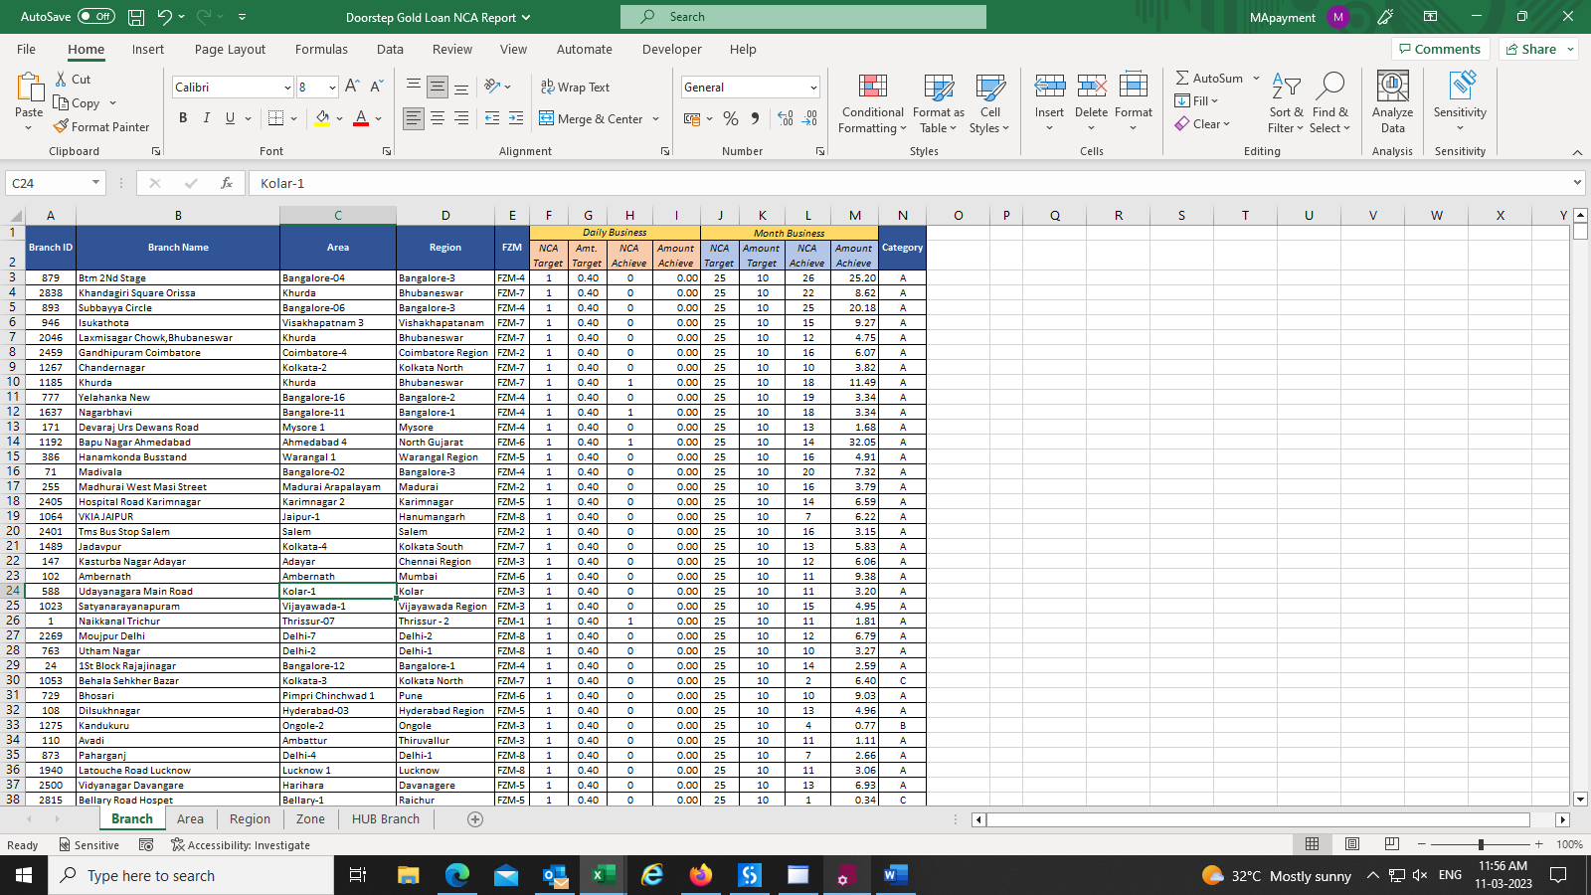

**Sending mail**

